## Monday

Objective: I will be able to identify past, present, and future tense verbs in a sentence.

Today we are going to learn/review the tenses of verbs.

First of all, let’s look at the following sentences and find the verb in each sentence.

1. Jeannie remembered to make her bed this morning.
2. Jake walks to school everyday.

The verb in the first sentence is *remembered*, and the verb in the second sentence is *walks*. A verb is a word that shows an action or a state of being.

**Verb tense** tells us **when** an action takes place. The **simple past tense** tells what has already happened. For regular verbs, add **-ed** at the end of the verb (or just **-d** if the verb ends in an e):

Play → Play**ed**

Hope → Hope**d**

Listen → Listen**ed**

Like → Like**d**

The **simple present tense** is when an action happens regularly or is always true. The verb stays the same but for third person singular(he/she/it), you always add -s at the end of the verb.

For example:

John **sleeps** eight hours every night during the week.

It **rains** a lot in winter.

The **future tense** tells what will happen, we use the helping verb will + base form of the verb.

Examples:

They will play football in that field.

Bob will go to the library tomorrow.

Please complete the following worksheets to practice past, present, and future tense verbs.

Name: ____________

Past, Present, and Future Tense Verbs

Underline the action verb in each sentence. On the line, tell whether the verb is past tense, present tense, or future tense.

Examples:

Daniel played baseball yesterday. past tense

He plays baseball everyday. present tense

We will go to Daniel's baseball game. future tense

1. Daniel will choose a baseball bat. _____________________________
2. He steps up to the plate. _____________________________
3. The pitcher tossed the ball. _____________________________
4. Daniel will swing hard. _____________________________
5. The ball struck the bat. _____________________________
6. The ball flies through the air. _____________________________
7. It landed over the fence. _____________________________
8. Daniel will run around the bases. _____________________________
9. The crowd screams loudly. _____________________________
10. He will slide into home plate. _____________________________
11. Daniel's teammates cheered. _____________________________
12. Daniel smiled proudly. _____________________________

Name _________________

Past, present or future tense

Write if the sentence is in the past, present or future.



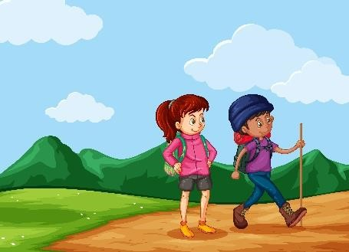__ Past__ 1. They climbed that hill easily.

________ 2. We will travel to Europe next summer.

________ 3. They play soccer in the sunshine.

________ 4. The children ate their vegetables.

________ 5. You will see your best friend next weekend.

________ 6. She brushes her teeth every night.



Write a sentence about playing basketball in each tense.

Past

____________________________________________________________

Present

____________________________________________________________

Future

____________________________________________________________

Name _________________

Past, present or future tense

Write if the sentence is in the past, present or future.



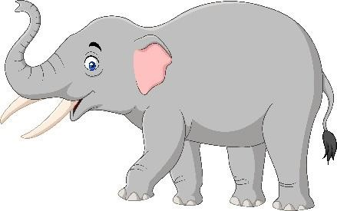__Present_ 1. Elephants have long trunks.

_________ 2. Our family visited Africa last year.

_________ 3. Some say insects will rule the world one day.

_________ 4. Melissa finished her research project.

_________ 5. Mark wears a T-shirt.

_________ 6. The school year will end in June.



Write a sentence about helping friends in each tense.

Past

____________________________________________________________

Present

____________________________________________________________

Future

____________________________________________________________

# Tuesday

Objective: I will be able to use my reading comprehension skills to answer questions.

Reading comprehension

Read the following passage, answer the questions using information you learned from the passage. Each of the vocabulary words below are used in the reading passage. As you read the passage, write the meaning of each word using context clues.

1. Millennia ___________________________________________
2. Ancient ___________________________________________
3. Equestrian ___________________________________________
4. Coincided ___________________________________________
5. Secular ___________________________________________
6. Intent ___________________________________________
7. Showcase ___________________________________________
8. Global ___________________________________________
9. Grandeur ___________________________________________
10. Massive ___________________________________________

**The Olympics**

Passage retrieved from ReadingVine.

People all over the world watch the Olympic Games on TV, cheer on their nations’ athletes, and get into the spirit of friendly international competition. Yet how many people know how these games came about and why they were created? Why is there an Olympic torch? What does the flag with the colored rings represent? Looking back in time a few millennia can answer those questions.

The first Olympic Games in recorded history took place in 776 BC on the ancient plains of Olympia in southern Greece. Athletes competed in running, long jump, shot put, javelin, boxing, and equestrian events. These ancient games coincided with a religious festival and were dedicated to the Olympian gods. They continued for almost twelve centuries until Emperor Theodosius banned them in AD 393 due to their pagan nature. Though linked to the cult of Zeus, in reality, the aim of the games was more secular. The intent was to show off the physical strength of the youth and to encourage good relations among the city-states of Greece.

The Olympics as we know them today have a similar purpose. Their intent is to showcase the strength and talents of the world’s best athletes while bringing the countries of the world together.

That unity is the reason for the five interlocking rings on the Olympic flag. They represent the continents of North and South America, Asia, Europe, Africa, and Australia coming together.

It was about 1500 years after the last Olympics that the ancient games were revived. Baron Pierre de Coubertin, a Frenchman dedicated to the promotion of physical education, was inspired to create a modern Olympic Games after he visited the ancient Olympic site. Coubertin eventually won the support of an athletic organization in Paris. They gave him their approval to form an International Olympic Committee. It remains the governing body of today’s Olympic Games.

The first modern Olympic Games took place in Athens, Greece, in 1896. Since then, they have grown in size. What started in Athens with 43 events, 280 athletes, and 13 countries returned to Athens in 2004 with nearly 11,000 athletes representing 201 countries.

Each Olympics since 1896 has been numbered, even when no actual games took place. The games were cancelled three times due to global conflicts. They were not held in 1916 during World War I or in 1940 or 1944 during World War II.

Even the opening and closing ceremonies have grown in size and scope. The first opening ceremony was in 1908 at the London Olympics. Host cities have been trying to outdo each other ever since.

Interestingly, the Olympic torch was lit for the first time at the opening ceremony of the 1936 games in Germany. The ancient Greeks had a ritual fire for their games, but the idea of lighting a torch in Olympia and relaying it to the sight of the games actually belongs to Carl Diem. He was the chief organizer of the Berlin games. Hitler was skeptical of holding the games at first but became convinced that connecting the Third Reich to the grandeur of ancient Olympia was a good idea.

Because of the massive devastation of World War II, the torch was not lit again until the 1948 games in London. Although the tradition was created in Nazi Germany, a recent enemy, Britain embraced the idea of lighting a torch in Greece, relaying it to the games, and this time hailing it as a “relay of peace.” Symbolically, the first torchbearer in Greece laid down his weapons and removed his army uniform before grasping the blazing torch.

The games have continued uninterrupted since 1948. A minor change did take place in 1994 when the timing of the Summer and Winter Olympic Games was changed so that they would not be held in the same year. They are now held separately, alternating every two years.

The revival of this ancient tradition has become one of the world’s premier sporting events. It has served as a way to honor remarkable athleticism and to bring many nations together in the pursuit of something positive. The Olympic torch will most likely continue to be lit for some time to come.

Questions: Each answer should contain at least 4 sentences.

1. According to the author, what are two of the main purposes of the Olympics?

1. What can you infer about the meaning of the words *pagan* and *secular* based on the context of the second paragraph of the passage?

1. The Olympics are full of symbolism. Why was the Greek torchbearer removing his uniform in 1948 symbolic?

1. Based on the passage, do you think the author has a favorable or unfavorable view of the Olympics? Cite evidence from the text to support your opinion.

# Wednesday

Objectives: I will be able to identify and use irregular verbs in a sentence.

Monday, we learned about simple past, present or future tense**. Verb tense** tells us **when** an action takes place. The **simple present tense** is when an action happens regularly or is always true. The verb stays the same but for third person singular(he/she/it), you always add -s at the end of the verb.

For example:

John **sleeps** eight hours every night during the week.

It **rains** a lot in winter.

The **future tense** tells what will happen, we use the helping verb will + base form of the verb.

Examples:

They will play football in that field.

Bob will go to the library tomorrow.

The **simple past tense** tells what has already happened. For regular verbs, add **-ed** at the end of the verb (or just **-d** if the verb ends in an e):

Play → Play**ed**

Hope → Hope**d**

Listen → Listen**ed**

Like → Like**d**

Example Sentences Using Irregular Verbs

be → was / were

Tom **was** in New York yesterday. They **were** at the party last weekend.

Below is a list of common irregular verbs.

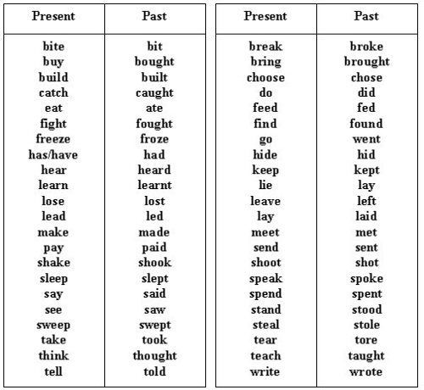

Please complete the following worksheets to practice past, present, and future tense verbs.

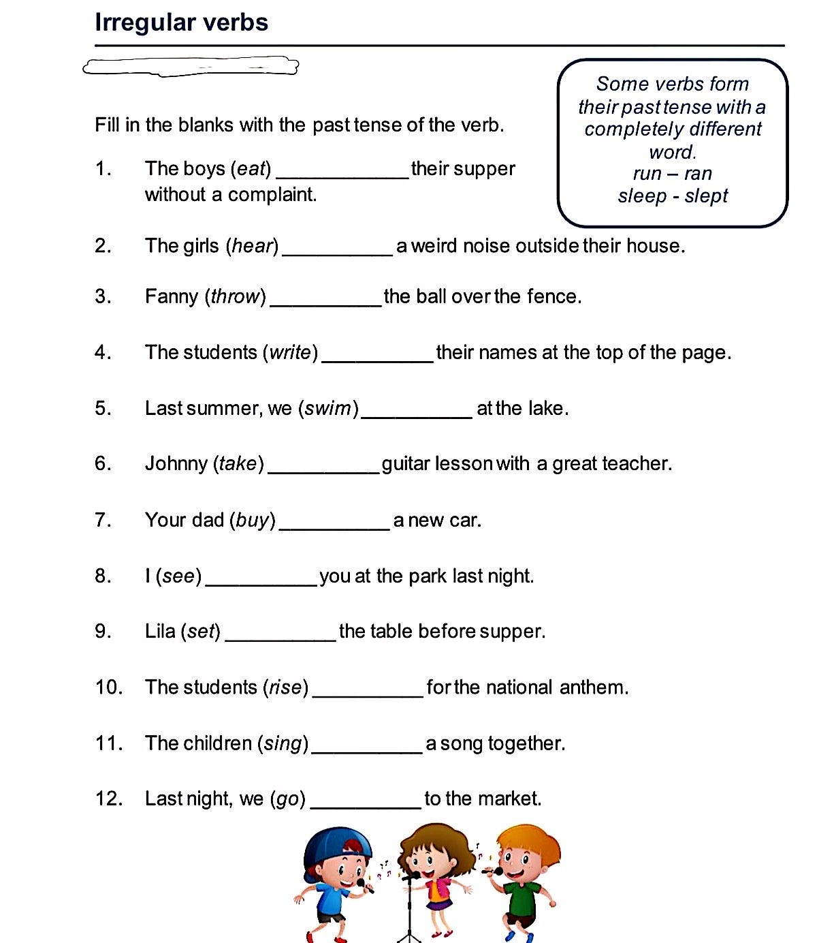

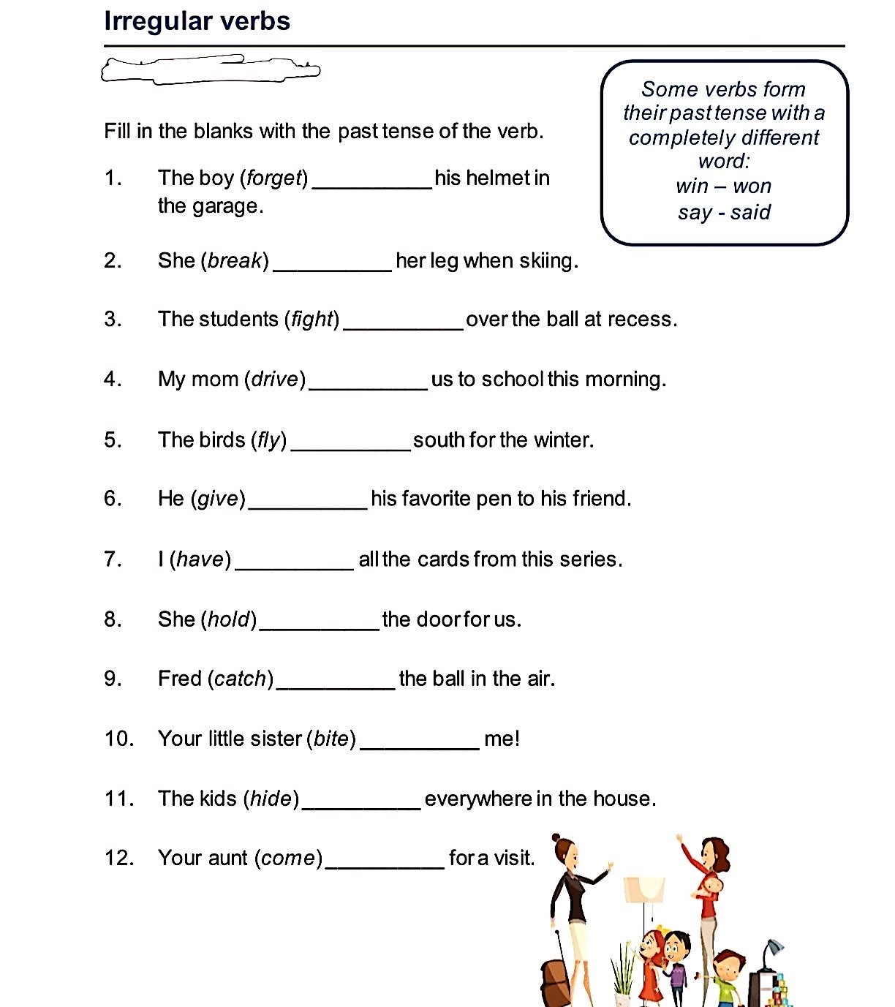

Name _________________

Past, present or future tense

Write if the sentence is in the past, present or future.

___

Past

__

1

.

The squirrel

hid

nuts in his nest.

_________

2

.

Bears hibernate in the winter.

_________

3

.

Winter will be long this year.

_________

4

.

A new movie will come out on Friday.

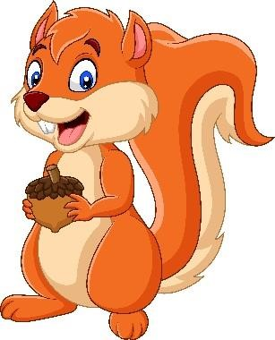

_________ 5. We are ready for school.

_________ 6. Mom made our lunches for us.



Write a sentence about going to movies in each tense.

Past

____________________________________________________________

Present

____________________________________________________________

Future

____________________________________________________________

# Thursday

Objective: I will be able use my writing skills to write a persuasive letter.

Finish up the reading comprehension questions from Tuesday.

If you are done with the questions, you can start the writing assignment.

Writing activity: You want to start a new sports club at your school, and you have to write a letter to your principal to convince her to allow you to start this sports club. You can pick any sports you want. If your school already has the sports club you want to write about, it is fine, pretend like it doesn't exist. In your letter, be persuasive. Remember, you're trying to convince someone, so you have to list the positive effects of having this sports club.

# Friday

Objective: I will be able to identify present progressive tense and use the correct form of the verb.

On Monday and Wednesday, we learned about the simple past, present, and future tense. With the knowledge we have, we are going to learn the present progressive tense, which is also known as present continuous tense.

The present progressive tense indicates continuing action, something going on now. This tense is formed with the helping "to be" verb, in the present tense, plus the present participle of the verb (with an **-ing** ending):

Examples:

I am buy**ing** all my family's holiday gifts early this year.

She is work**ing** through the holiday break.

The present progressive can suggest that an action is going to happen in the future, especially with verbs that convey the idea of a plan or of movement from one place or condition to another:

Examples:

The team is arriv**ing** in two hours.

He's mov**ing** to Portland this summer.

**Forming the Present Progressive Tense**

|  |  |  |
| --- | --- | --- |
| **Subject** | **Verb "to be"** | **Present Participle** |
| I | am | [verb] + "ing" |
| You | are |
| He / She / It (or singular noun) | is |
| We | are |
| You | are |
| They (or plural noun) | are |

For example:

* She is running.
* I am talking.
* You are jumping.

**Spelling Tip**

Verbing (Present Participle)

* Add ing to most verbs. Ex. play → play**ing**, cry → cry**ing**, bark → bark**ing**
* For verbs that end in e, remove the e and add ing. Ex: slide → slid**ing**, ride → rid**ing**
* For verbs that end in ie, change the ie to y and add ing. Ex: die → dy**ing**, tie →ty**ing**
* For a verb whose last syllable is written with a consonant-vowel-consonant and is stressed, double the last letter before adding ing. Ex: beg → beg**ging**, begin → begin**ning**. However: enter → enter**ing** (last syllable is not stressed).

Please complete the following worksheets to practice present progressive/present continuous tense.

